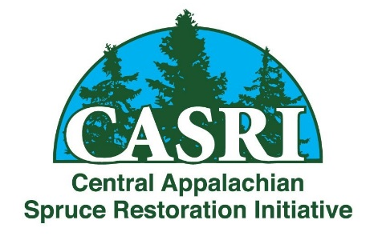
Conifer Health Colloquium and Field Tours
Conifer Conservation and Ecology in the Central Appalachians
Dates: October 16 – 17, 2019
Meeting Location: Blackwater Falls State Park Lodge
Field Trip Locations: Blackwater Falls State Park & Canaan Valley Wildlife Refuge
FREE – Public Welcome!
Sponsored by The WV Highlands Conservancy

Conifer Health Colloquium ~ ~ ~ October 16, 2019
2:45 – 3:30p | Hemlock Forest Health Monitoring, Treatment and Ecology  John Perez, Biologist, New River Gorge National River & Gauley River National Recreation Area
3:30 – 3:45p | Update on Hemlock Health and Treatment in the Central Appalachians  Amy Hill, Forest Stewardship Coordinator, State and Private Forestry, USDA Forest Service
3:45 – 4:00p | Break
4:00 – 4:30p | Balsam/Canaan Fir Research Updates  Hessl Lab, Geography, WVU
4:30 – 5:15p | Balsam Fir Woolly Adelgid Resistance and Management  Ben Smith, Research Scientist, Forest Restoration Alliance
5:15 – 6:00p | Speaker panel discussion on conifer conservation in the Central Appalachian Highlands
Field Tours ~ ~ ~ October 17, 2019
9:00a | Gather at the Blackwater Falls State Park Lodge entrance to carpool for field tours
9:15 – 12p | Site visits in the Blackwater Falls State Park focus on Hemlock Woolly Adelgid research and treatment plots.
12 – 1p | Lunch @ restaurants in Davis, WV
1 – 2:30p | Site visits in Canaan Valley focus on balsam (Canaan) fir research and restoration sites undertaken by The Nature Conservancy, Canaan Valley National Wildlife Refuge, West Virginia University, and Canaan Valley State Park.
2:30 – 3:30p | chairlift ride to the top of Weiss Knob for views of a mature spruce forest, as well as topography of the Canaan Valley area that enables fir trees to thrive

RSVP at restoreredspruce.org

